Developing a Backend Admin for Learner’s Academy

**Developed by Rakhi Kale**

**Email:** kalerakhi2613@gmail.com

**Flow Chart:**

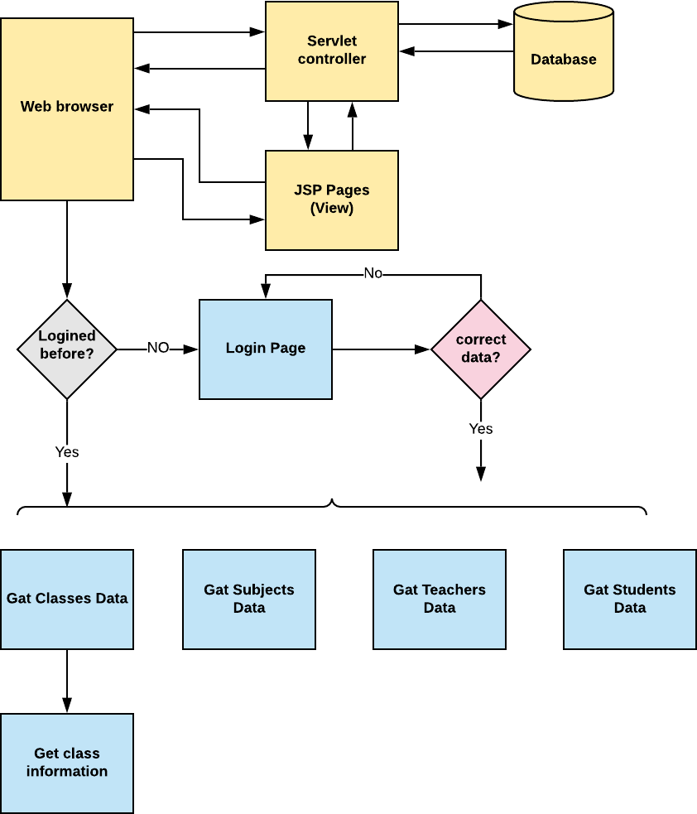

# Application Flow:

* Whenever the application is opened and admin login interface will be displayed, the admin needs to login into the application with proper credentials.
* Once the admin is logged in to the application a list of classes will be display besides multiple option of subjects, teachers, students and logout.
* If one of the options, say subjects is selected then a list of subjects will be displayed which are already saved in the database, with multiple option like delete, edit and create a subject.
* If the option teachers are selected a list of teachers with their assigned class from the database will be displayed, with multiple option delete, edit and create a teacher’s data.
* If the students are selected a list of students with their plan schedule will be displayed.
* If the option logout is select the admin will be logged out from the application

# Conclusion:

In the program an application has been developed with a duration of two spirits. This application makes handling the data of the learner’s academy. All the data about the classes, subject, teachers, students and their schedule are maintained. The admin can login through a User ID and password and manipulated the data.